**Before Administration**

1) Randomization information: (Create a randomization file to keep track of the randomization)[1]

Condition: H = Health; T = Taste;

1 = Good/Healthy on Left;

2 = Good/Healthy on Right

2) Food binder: 76 slides of food pictures – stimuli in the task

***If this is the FIRST time you are running the task,

1) You will also need to download [PsychoPy.](https://www.psychopy.org/)

2) Please make sure all the following folders/items (Item 2-6 in “Materials You Will Need for the Task”) are stored in one folder. For example, the file path should be “/Desktop/FCT_2022”

3) If you are not sure how the task should look like, see Appendix E for screenshots of the task

3) Standardized lunch at 12 PM (see Appendix A for lunch items)

4) Prepare questionnaires and paperwork for the task 1:30 – 3:30 PM

1) VAS & PANAS

2) Debriefing form for food choice task

**Materials You Will Need for the Task**

**1**. Food choice task manual (this document)

**2**. Python scripts: a) Behavioral Food Choice: FCT_2023; fct_library; constants; run

b) Food Choice Task for fMRI: FCT_MRI_2023, fct_library; constants; run_MRI

**3**. Data folder: where subject data stores at the end of experiment

**4**. Lists folder: h/t/c list selection (6 lists in total)

**5**. Order folder: orders of healthy/taste section (4 conditions in total)

**6**. Stimuli folder: 76 food pictures

**Before Task 1:30 – 2 PM**

**1.** Administer VAS & PANAS

**2.** Go over the **food binder** with participants. If participants have any restriction on food (allergy, diet), see Appendix B for more information.

**Task Administration at 2 PM**

**\*\*\* The task will last 24 - 25 minutes: 8 minutes for each block (health/taste/choice).**

**1.** OPEN the task folder

**2.** OPEN PsychoPy and GO TO **the Coder** view

**3.** DRAG **run.py** OR run_MRI into the **Editor** tab in Coder view

**4.** CLICK **THE GREEN RUN** BUTTON ON THE TOP

Enter subject info.

Enter participant: Study ID

Enter order: Condition_1_HT/1_TH/2_HT/2_TH

Enter h_list: foodlist 1/2/3/4/5/6 [To test, use ‘Test/1/2’]

Enter t_list: foodlist 1/2/3/4/5/6 [To test, use ‘Test/1/2’]

Enter c_list: foodlist 1/2/3/4/5/6 [To test, use ‘Test/1/2’]

**PRESS OK** TO START THE TASK.

**IMPORTANT: Task Script, see Appendix C**

**The End of Experiment**

The end of the task is ‘End of experiment. Thank you for participating.’

**1.** If the task stays on this page, ask the participants to press any key to end the task.

**2.** Complete the **Post-Task Debriefing Form** with the participant (see Appendix D).

**3.** Determine the snack item for the participants:

After the experiment ends, you will see a list of snacks in “…_choiceoutput.txt” file. There are 5 options. Choose one of the snacks in the file and give the snack to patient.

**Output and Data Collection**

All the data will be automatically stored in the folder called ‘data’ under the same folder where the task is stored:

i.e. FCT_2022_Py/data, see below.

*** Note: yellow rice_beans is the dummy food item in the choice phase, therefore, it does not have any of h_rating, h_rt, t_rating, t_rt.

**Troubleshooting**

**On Macbooks:**

If the program freezes, option + command + esc will quit PsychoPy. (If the program does not respond to one press, double press will ensure the program quit)

If the program aborted before it finishes, take a screenshot of the PsychoPy error message (COMMAND + SHIFT + 4) and select the area of the screen containing the message. Save the screenshot with a date and put it in the folder on the desktop containing PsychoPy errors. Make a note of the error.

**On Windows:**

Force quit is Alt + F4.

**Task Scoring**

To retrieve usable task output files, including the trial-by-trial data, and choice/rating summaries by fat content of the food items, you will need to run the scoring script (FCT_scoringscript.R). You will need R, and Rstudio, available here: https://posit.co/download/rstudio-desktop/

Before beginning, make sure all data are saved to a study specific folder than contains only the task data (i.e., data in the example above). If you followed the instructions for running the task above, you should not need to change the file structure, which will look like this:



Next, open the scoring script in Rstudio or R. Change the working directory as appropriate (line 15). This should be the study specific folder, in which your subjects are placed (in our example “~/Documents/FCT_2022_Py”).

Now hit the run button to produce a summary file (“FoodChoice_SUMMARY_csv”) and a trial-by-trial file (“FoodChoice_TRIALBYTRIAL.csv”). These files will save with the current date, and in the study folder (“~/Documents/FCT_2022_Py”).

The trial-by-trial data file includes health, taste, and choice rating and reaction time data for each trial or food, for each participant of the study. The summary file includes the following variables (the **bolded** variables are those most commonly reported) for each participant:

|  |  |
| --- | --- |
| SubID | Subject ID |
| Date | Date completed |
| hlist | List run for Health |
| tlist | List run for Taste |
| clist | List run for Choice |
| ref | Reference food |
| ref_h | Health rating of reference food |
| ref_t | Taste rating of reference food |
| re_ord | Response order (order of scale) |
| **h_resp** | **Proportion responses on Health trials** |
| **t_resp** | **Proportion responses on Taste trials** |
| **c_resp** | **Proportion responses on Choice trials** |
| **h_lo** | **Mean ratings on Health trials - Low fat** |
| **h_hi** | **Mean ratings on Health trials - High fat** |
| **t_lo** | **Mean ratings on Taste trials - Low fat** |
| **t_hi** | **Mean ratings on Taste trials - High fat** |
| c_lo | Mean ratings on Choice trials - Low fat |
| c_hi | Mean ratings on Choice trials - High fat |
| cneu_lo | Proportion neutral choice (neither food or reference) - Low fat |
| cneu_hi | Proportion neutral choice (neither food or reference) - High fat |
| **cho_noneut_lo** | **Proportion trials food chosen over reference when neutral responses (3) are excluded - Low fat** |
| **cho_noneut_hi** | **Proportion trials food chosen over reference when neutral responses (3) are excluded - High fat** |
| **self_ctrl_bin** | **Proportion of trials on which self-control could be implemented out of relevant trials (i.e., trials in which taste and health were in conflict)** |
| self_ctrl_bin_count | Number of trials on which self-control could be implemented (i.e., trials in which taste and health ratings were in conflict) |
| **self_ctrl** | **Proportion of trial with self-control out of the trials on which that was possible (i.e., the trials that are in self_ctrl_bin variable).** |
| h_lo_rt | Median RT Health - Low fat |
| h_hi_rt | Median RT Health - High fat |
| t_lo_rt | Median RT Taste - Low fat |
| t_hi_rt | Median RT Taste - High fat |
| c_lo_rt | Median RT Choice - Low fat |
| c_hi_rt | Median RT Choice - High fat |

**Appendix A**

Inpatient Research Lunch depend on their scheduled calorie intake.

**1800/2200 Kcal Diet:**

SANDWICH: 4 oz wt. Turkey Breast; 2 slices Whole Wheat Bread; 1 packet Mayo (spread on bread)

Nutri-Grain Bar

Spring Water - 8 fl. oz.

**1800/2200 Kcal Diet (Vegetarian/Pescatarian):**

SANDWICH: Peanut butter (thinly spread) and one jelly (spread) on two slices whole wheat

Nutri-Grain Bar

Spring Water - 8 fl. oz.

**2600/3000 Kcal Diet:**

SANDWICH: 3 oz wt. Turkey Breast; 2 slices Whole Wheat Bread; 1 packet Mayo (spread on bread)

3 Nabisco Homestyle

Chocolate Chip Cookies

1 Apple

8 fl. Oz. Whole Milk

**2600/3000 Kcal Diet (Vegetarian/Pescatarian):**

SANDWICH: Peanut butter (thinly spread) and one jelly (spread) on two slices whole wheat

3 Nabisco Homestyle

Chocolate Chip Cookies

1 Apple

8 fl. Oz. Whole Milk

**Appendix B**

**IF THE PARTICIPANT HAS DOCUMENTED ALLERGIES…**

When completing food binder with participant prior to task, identify all the foods to which the participant is allergic. Make note of these foods on the participant’s data sheet. Confirm with allergies in clinician or unit note.

*When you see these foods during the task, please give them the lowest possible rating.*

*Doing so will ensure that an allergy food is not the reference food for the participant’s task.*

**IF THE PARTICIPANT IS KOSHER/HALAL (OR GLUTEN FREE) …**

Identify all the foods that are not kosher/that have gluten in them. Make note of these foods on the participant’s data sheet.

*When you see these foods during the task, please imagine that you are seeing the kosher/gluten-free version of this food (i.e., imagine that the pretzels are kosher, meat is kosher, bread on the turkey sandwich is gluten free, etc.)*

Get kosher/gluten-free version of snack that comes up. If you are unable to get a kosher/gluten-free version of the number one snack, go down the list.

**IF THE PARTICIPANT IS LACTOSE INTOLERANT…**

If the participant has a documented lactose sensitivity or intolerance and they are an outpatient or healthy control, instruct that they will get lactaid.

**IF THE PARTICIPANT IS VEGETARIAN/VEGAN…**

Do not change your instruction for the task. We will not, for example, substitute a meat-free or dairy-free version of any of the foods, unless it is for the reasons above (allergies/sensitivities/religious reasons).

**IF THE PATIENT ASKS FOR MORE INFORMATION…**

For other items, we do not specify any nutritional information. We are happy to tell you afterward but we have to leave them with the description we discussed to keep everything standardized between patients

**Appendix C**

**Experimenter:** Now you will be seeing pictures of food and rating them. You will rate food items on a scale from 1 to 5 by pressing numbers 1 through 5. You will have about three and a half seconds to make each rating. The trials are timed—if you take too long to rate an image, the words “TOO LATE!” will appear on the screen. Don’t worry about this, it just gives you a sense of how long you have to rate each image. Specific instructions will appear on the screen and I’m going to ask you to read all of the instructions out loud to me.

**Participant:** *You will see a series of pictures of food. For each picture, please rate how Healthy/Tasty you think it is. You can rate each picture as ‘Neutral’ or on a scale from ‘Unhealthy/Bad’ to ‘Healthy/Good’. 1 being ‘Unhealthy/Bad’, 3 being ‘Neutral’, and 5 being ‘Healthy/Good’. If you have not eaten that food in a long time or never eaten it, please try to remember the last time you ate it, or think of a comparable food and rate it as best you can for how tasty you think it is. There are no right answers. Please rate only according to how unhealthy/bad or healthy/good you think that food is/tastes. It is important that you give an answer on each trial.*

**Experimenter:** Any questions? Okay, now we’re going to start.

PRESS KEY TO BEGIN TASK.

FIRST TASK BLOCK FINISHES AFTER ABOUT 8 MINUTES.

**Experimenter**: Okay, this next task is similar, but you will be asked to rate the food items in a different way. Please make sure that your fingers are still on numbers 1 through 5, and again read the instructions out loud to me.

**Participant:** *You will see a series of pictures of food. For each picture, please rate how Healthy/Tasty you think it is. You can rate each picture as ‘Neutral’ or on a scale from ‘Unhealthy/Bad’ to ‘Healthy/Good’. 1 being ‘Unhealthy/Bad’, 3 being ‘Neutral’, and 5 being ‘Healthy/Good’. If you have not eaten that food in a long time or never eaten it, please try to remember the last time you ate it, or think of a comparable food and rate it as best you can for how tasty you think it is. There are no right answers. Please rate only according to how unhealthy/bad or healthy/good you think that food is/tastes. It is important that you give an answer on each trial.*

**Experimenter:** Any questions? Okay, now we’re going to start.

PRESS KEY TO BEGIN TASK.

SECOND TASK BLOCK FINISHES AFTER ABOUT 8 MINUTES.

**Experimenter:** For this final task, you will be making choices. Again, please check that your fingers are on numbers 1 through 5 and again read the instructions out loud to me.

**Participant:** *Now you will be asked to choose a food to eat. On each trial, you will see this reference food on the left- it is always the same. On the right the choice will change on each trial. For each picture, indicate whether you ‘Prefer’ or ‘Strongly prefer’ the food on the right or instead ‘Prefer’ or ‘Strongly prefer’ the reference food on the left. If you really cannot choose between the two pictures, you may indicate ‘Neutral.’ Please be sure your choices accurately reflect your preferences. Imagine that you will have to eat a snack sized portion of one of your preferred items, randomly selected at the end of the task.*

**Experimenter:** Any questions? Again, please be sure to make your rating based on what you actually want as a snack because you will be served a snack after the task based on your choices. Okay, now we’re going to start.

PRESS KEY TO BEGIN TASK.

During the final task, you will see the reference food snack on the left side of the screen.

CHOICE BLOCK FINISHES AFTER ABOUT 8 MINUTES.

**Appendix D**

**What was the Reference Food you were asked to compare the other foods with?**

**How HEALTHY do you think that food is, on a scale of 1 – 5 (1 = unhealthy and 5 = healthy) ?**

1 2 3 4 5

Unhealthy Neutral Healthy

**How TASTY do you think that food is, on a scale of 1 – 5, (1 = bad and 5 = good) ?**

1 2 3 4 5

Bad Neutral Good

**Did you find it easier to rate the HEALTHINESS or the TASTINESS of foods?**

**Did you feel you had enough time to make decisions about each food?**

**During the Task, how did you go about making your choices?**

**🡪 Did you have any particular strategies (for rating H & T)?**

**🡪 Did you find yourself making calorie calculations?**

[After asking open-ended Q’s, ask pt. the following multiple-choice questions]

**Specifically, when you rated the health of food items, what aspects did you consider?**

**a. Mainly fat content**

**b. Mainly how it would make me feel to eat the food**

**c. Mainly calories**

**d. Mainly vitamin/nutrient content**

**e. Other:** _____________________________________________

**And when you rated the taste of the items, what aspects did you consider?**

**a. Mainly taste**

**b. Mainly how it would make me feel to eat the food**

**c. Mainly calories**

**d. Mainly vitamin/nutrient content**

**e. Other**:_________________________________________

**When you were rating the food images:**

**🡪 Did you think the food pictures were appetizing? Were there any items that you would have changed your ratings for IF their presentations were different in the pictures?**

**How was it for you knowing you were going to have a snack after?**

**Anything else you think we should know?**

**Appendix E**

Instructions for rating healthiness of food

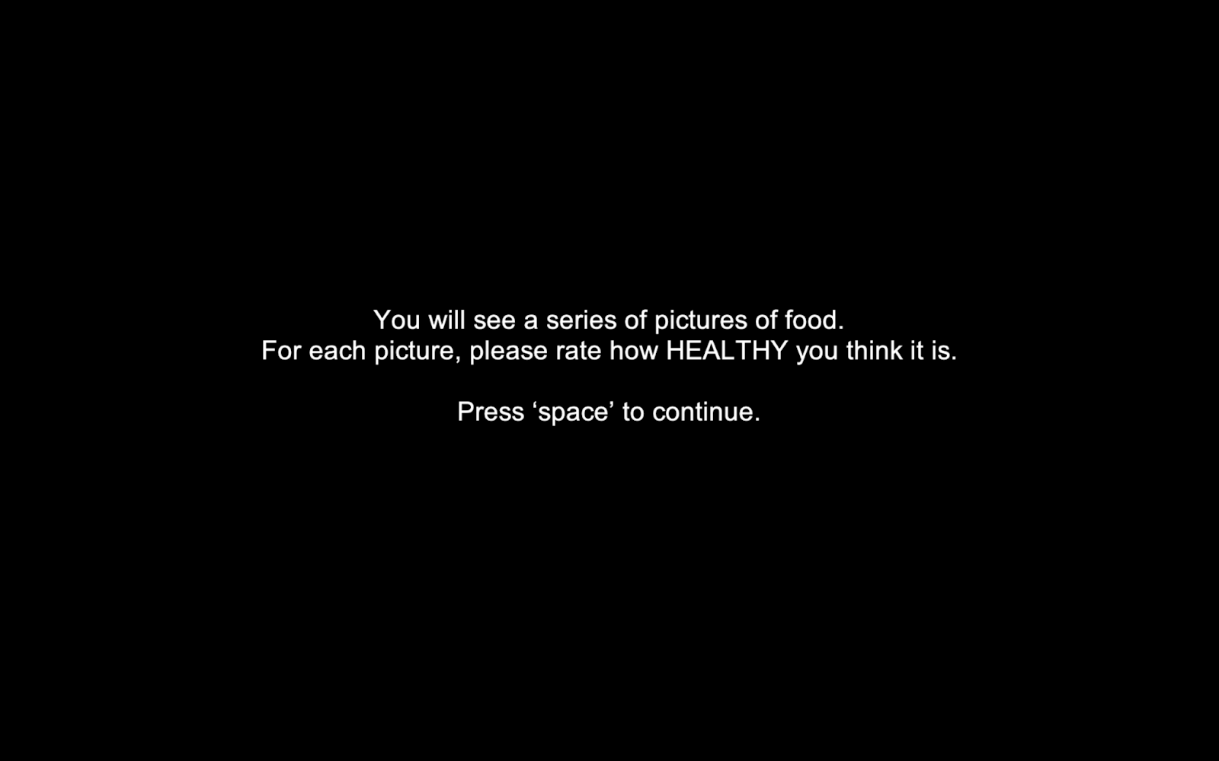

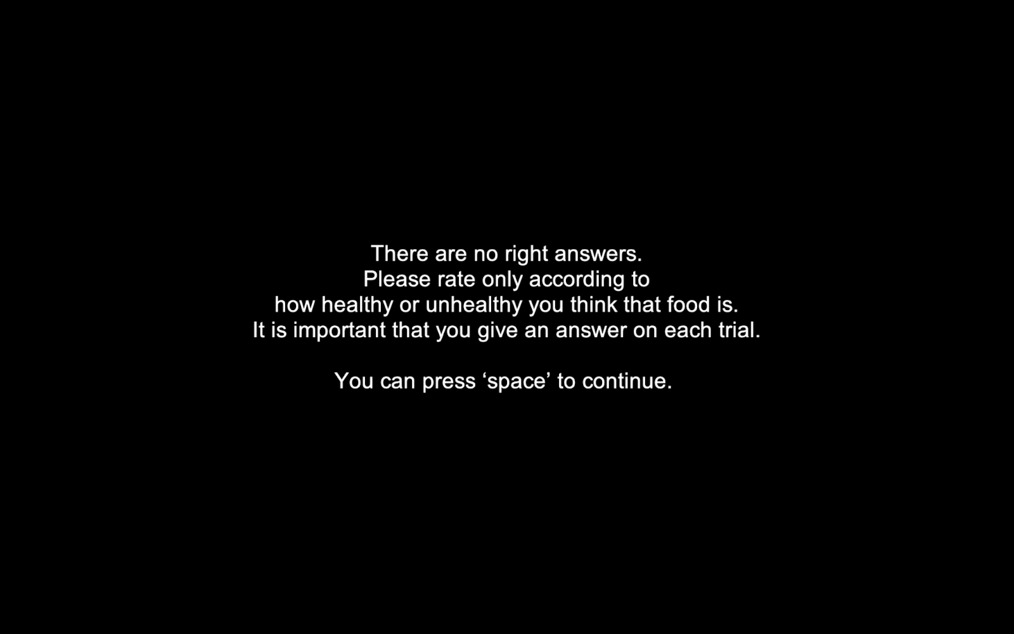

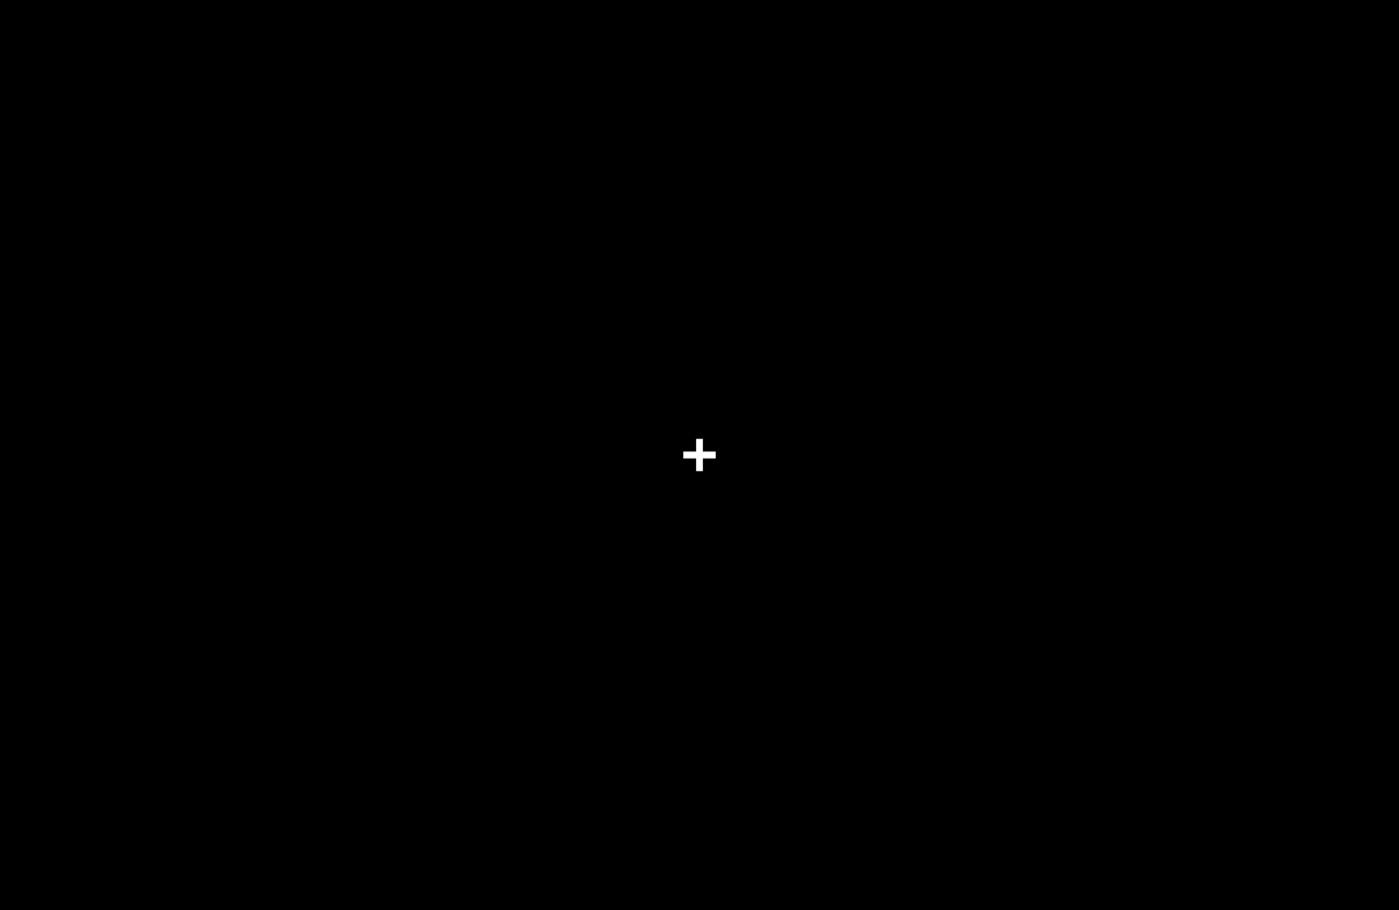

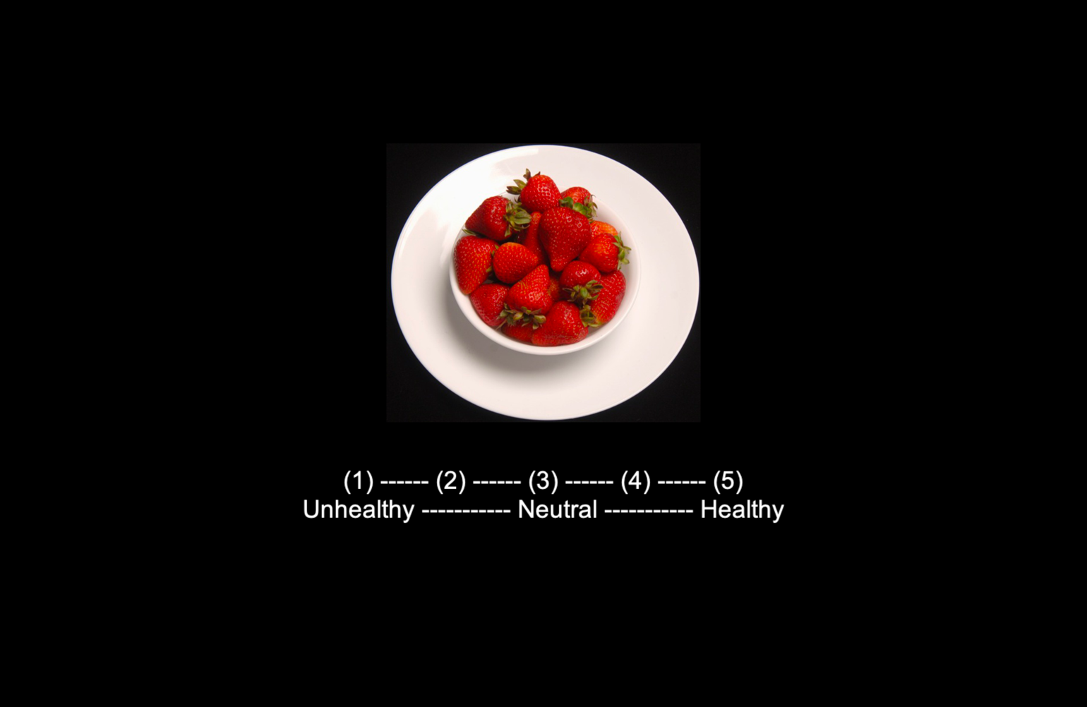

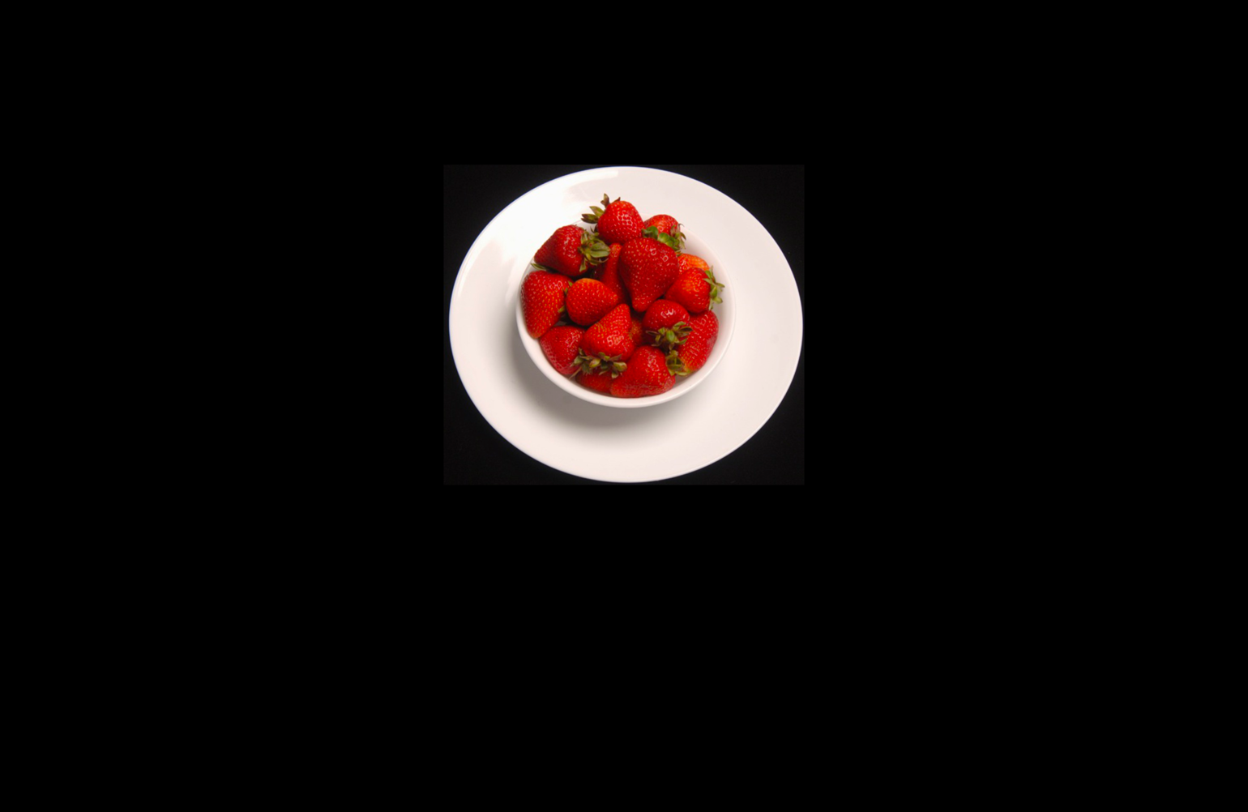

There are 76 trials in total in this block.

Instruction for rating tastiness of food

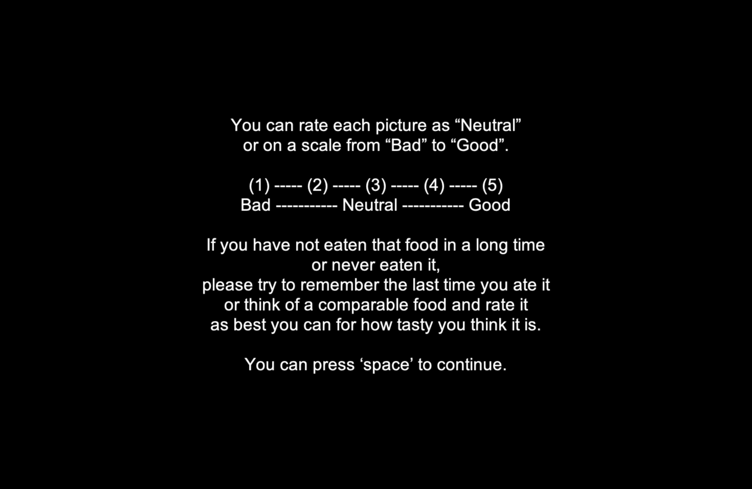



There are 76 trials in total in this block.

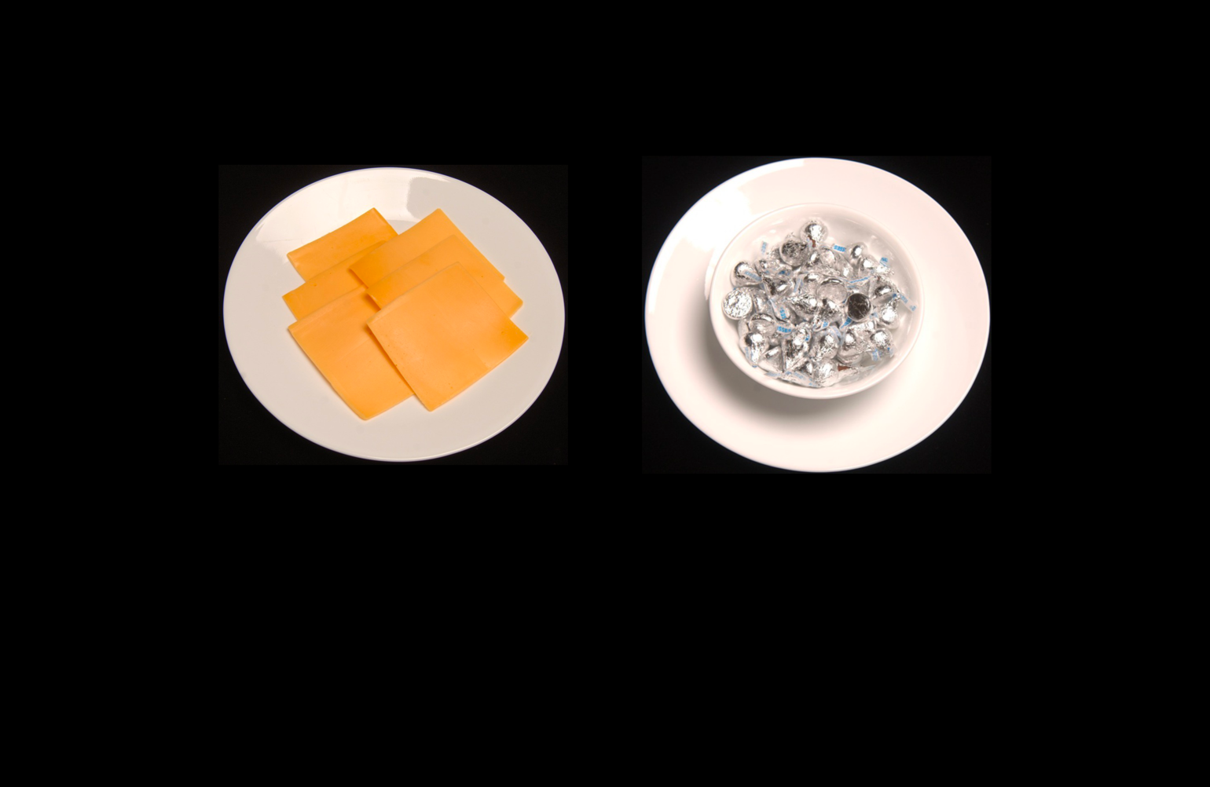

There are 76 trials in total in this block.

1. Health and Taste are counterbalanced across participants to balance any potential order effects. The presentation of rating scales (i.e., Good/Healthy on Left or Right) is randomized across participants to prevent systematic bias from the anchor presentation. The randomization applies to taste AND health trials, and so you will only have one value.